Introduction to Cloud Solutions Lab Report
Use this template to document your work as you complete the lab assignment in QA.

Your Information
Your Name:
Lab Title: Creating AWS EC2 Instances Using Templates

Instructions
Follow the instructions to answer the questions related to the lab and add the required screenshots. Submit your completed report following the instructions in Canvas.

Section 1
1. Step 10: What do the YAML and JSON templates share in common?
Both organize data using key-value pairs and can hold the same template information.
2. Step 10: How do the YAML and JSON templates differ from one another?
JSON uses braces, brackets, commas, and quotes. YAML uses indentation and is easier to read but spacing-sensitive.
3. Step 14 Screenshot: YAML template with URL
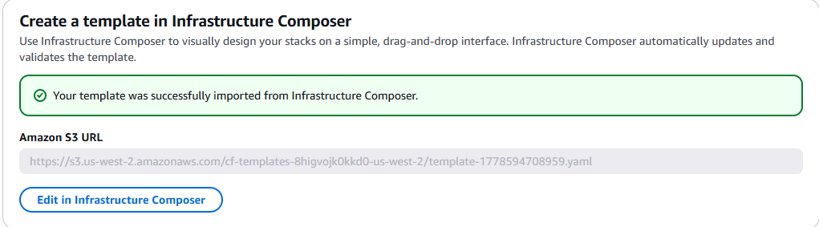

4. Step 30 screenshot: JSON template with URL
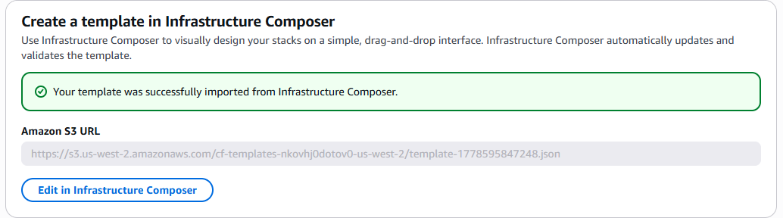

Section 2
5. Step 14: If you received a validation error, what steps did you take to resolve it?
I read the error, found the problem, corrected formatting or missing fields, then validated again.

6. Step 14: What do validation errors indicate about the contents of template file?
The template has something wrong, such as bad formatting, missing data, or incorrect values.

7. Step 17 screenshot: YAML template with URL
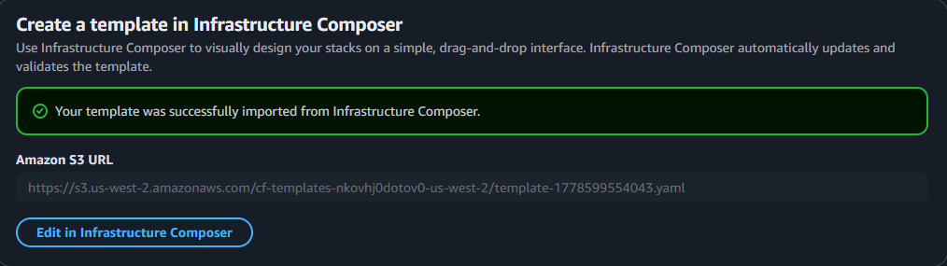

8. Step 28 screenshot: YAML template named stack (include your student ID)
